Isaac Amos, Omokehinde Omotosho, Jeff Asante
ENGL 21007
Professor Stemberg
8 April 2024
AI study Lab report
Abstract
The primary objective of this lab report is to give a detailed breakdown and analysis on the many forms of bias in the generative artificial intelligence released to the public. We investigated these biases through image generation with the parameters surrounding, race, gender, and age. My group members and I were ready to get started on our secondary objective which was to generate a hundred images using a gender-neutral profession as our keyword, using generators such as Bing and Canva image generators. In total, we generated 300 images with our 3 keywords, and with the results we arrived at, we found biases based on race, both genders and age groups. We all came to an emphatic conclusion that the AI image generation does indeed exhibit stereotypes and biases. Overall, the study highlights the significance of our hypothesis, which will be later discussed in the next section, our introduction.
Introduction
Artificial intelligence first became a thing about 70-odd years ago when Alan Turing published a journal article that proposed a test of machine intelligence called the imitation game. Over the years, its accessibility increased until it officially became open to the general public in the year 1980 with a variation known as XCON, expertly configured, was designed to help the consumer in selecting the most efficient computer components according to the consumer’s needs. As stated in the abstract, the primary objective of this lab report is to give a detailed breakdown and analysis of the many forms of bias in the generative artificial intelligence released to the public. The AI operates off the datasets provided and labeled by us humans and then sent into the AI tools learning algorithm. My group members and I generated a hundred images using gender-neutral professions as our keywords with the help of image generators such as Bing and Canva AI image generators. Before we began, my group members and I discussed, and we all agreed that the AI image generators will display many forms of bias in their generation due to issues with the datasets the AI is provided with by their companies. This experiment was important because we believe AI is the future of humanity. It is slowly integrating itself into all aspects of our lives, some that we may not even be aware of! Therefore, it is worth studying, to allow us to identify its limitations, which in turn will also allow us to improve upon our future as a collective! In the next sections, you will be provided with meticulous details on the methods we used to approach this experiment, the results we arrived at, a general discussion, and a summary of the primary outcomes of our research.

Materials and Methods
The group decided to use Bing AI as our image-generating platform. Since there was an instruction to choose gender-neutral terms and there were three of us in this group we decided to use the respective terms “Legal Consultant”, “Manager” and “Social worker”. Now with that out of the way. We each had to generate 100 images using Bing AI generator meaning our group had to collectively generate 300 images to later be analyzed for 3 characteristics. We did not add anything extra with our image-generating terms and searched the image as is. Although the generators take a little while to generate these images there's a need for great patience especially knowing that we must generate 100 images each. Although Bing AI image generator is convenient because it generates four images at a time. Now after each member had generated their images we decided to categorize and analyze the images by 3 characteristics age, race, and gender. To get access to the general census of each term we counted each individual one by one for each category.

Results
Jeff Asante-
Age 25-70
Race
White
Women-204
Men-303
African American
Men -34
Women-61
Asian
Men-14
Women-25
Gender
Men-348
Women-294

Omokehinde Omotosho
Age: 20-50 for the social worker
10-80 for client
Men - 70
Women - 101
African American
Men - 21
Women - 23
White
Women - 70
Men - 45
Asian
Men - 4
Women - 8

Isaac Amos

Age 30-50
*Race
White
Men-209
Women-184

African American
Men-31
Women-31

Gender
Men-240
Women-215

Race | Men | Women | Age | General gender/Men | General gender/Women | Total
African American | 34,21,31 | 61,23,31 | 20-70 | 348,70,240 | 294,101,215
Caucasian | 303,70,209 | 204,45,184 | 20-70
Asian | 14,4 | 25,8 | 20-70
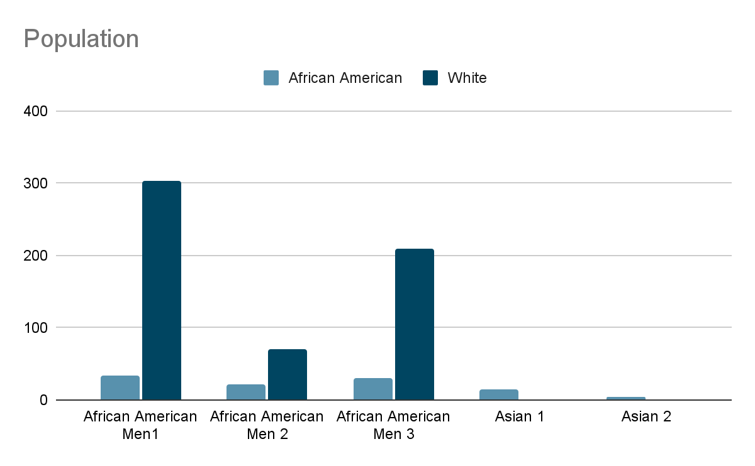

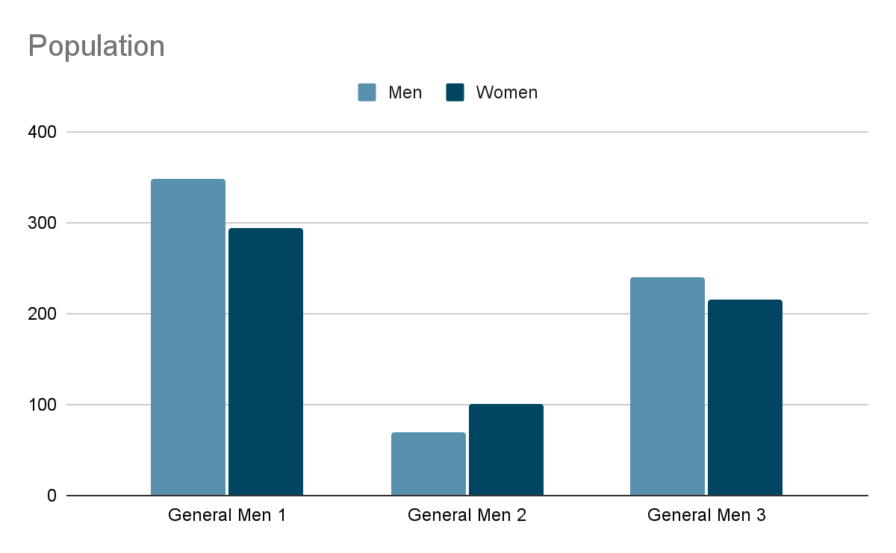
Discussion/Conclusion
So why does the AI show stereotype and bias, according to Chapman University “One of the primary sources of such bias is data collection. The resulting outputs may be biased if the data used to train an AI algorithm is not diverse or representative.”
Our analysis uncovered two major issues with these AI generators: systematic gender and racial bias, and subtle biases in facial expressions and appearances. Specifically, it showed bias against African Americans, which indicates these AI systems are amplifying harmful societal biases instead of working to reduce them.
We had some other problems that happened trying to get all the images, one of the problems was some of the images that were generated had too many people, so we had to look for the ones that didn't have too many people, another problem was the image generator which was being only give you 15 times to generator 4 pictures very quickly which is 60 images, and after that, it takes a while to generate it, so we had to wait longer as we needed 100 images. Another problem was trying to accurately count every person, sometimes there were a lot of people shown and some images showed a little part of someone like their hands or their head, so we found a way to calculate the image with consistency. Moving forward, the next step is to Collaborate to present our research methodology, findings, and significance, we plan to assign roles to each member of the groups such as speaker, data analyst, and others, we plan to work on Canva to make the presentation, also be ready to answer any question that is asked.
One method to create more inclusive and less biased AI-generated images is to diversify the training data and include a wide range of images representing different demographics, cultures, and perspectives, by expanding the training set it will enable the model to learn broader representations and avoid perpetuating biases. Another interpretation of the results we got might be that Stereotypes abound in society, so the AI images show an accurate description of society.
In conclusion, the experiment conducted did show that our hypothesis which was that AI image generation does exhibit stereotypes and bias was right.
We generated 100 images each of a gender-neutral term, and we all decided together to use Bing, after generating all the images we analyzed all of them and collected the data. The experiment was successful as we broke down and analyzed the many forms of bias in the generative artificial intelligence released to the world.

Citations
What is the history of artificial intelligence (AI)? (n.d.). Tableau. https://www.tableau.com/data-insights/ai/history#:~:text=1980%3A%20First%20conference%20of%20the
‌Bias in AI. (n.d.). Www.chapman.edu. https://www.chapman.edu/ai/bias-in-ai.aspx#:~:text=One%20of%20the%20primary%20sources

‌

